Code Reference

The code comprises of three folders cgi-bin, html, trans.

cgi-bin --- this consists of the cgi files.

Register.cgi ---------- the registration page
Dependency:
Style Sheets: otpei_login.css, gila.css
Change the database connectivity settings at the starting of the code

Login.cgi ----------- the login page
Dependency:
Style Sheets: otpei_login.css, gila.css
Change the database connectivity settings at the starting of the code

Sentence.cgi ------------ the single sentence translation page
Dependency:
Style Sheets: otpei_stylesheet.css, otpei_login.css, gila.css
Scripts: Yahoo-dom-event.js, connection-min.js, dragdrop-min.js, animation-min.js, editable.js, otpei_source.js

Web.cgi ---------------- the web translation page
Dependency:
Style Sheets: otpei_login.css, gila.css
Scripts: index.js

Translate.cgi ---------------- the page responsible for web translation. Downloads page, parses it, translates and integrates it with the user interface. The initial version of translate.cgi that does downloading, parsing, translating and reconstructing of web page was coded by Herve Saint-Amand of Universitaet des Saarlandes. The code was a freeware that will be given along with the Moses software. The code was modified and integrated with the user interface.
Dependency:
Style Sheets: gila.css, container-core.css, bpanel.css, mpanel.css, otpei_web_stylesheet.css
Scripts: Yahoo-dom-event.js, connection-min.js, dragdrop-min.js, animation-min.js, editable.js, otpei_web_source.js, container-min.js
Others: The lib and scripts folder in cgi-bin.
The lines of code to be changed are
- the ip address of the system and the ports on which Moses is running
Current code line: my @MOSES_ADDRESSES = map "202.41.92.138:10$_" qw/45/;
Suppose if the Moses server is running on a system with ip 172.16.13.54 and on port no’s 1067,1089 then the code will be
Modified code line: my @MOSES_ADDRESSES = map "172.16.13.54:10$_" qw/67 89/;
- the addresses of the tokenizer.perl and detokenizer.perl.
Current code line:
my @TOKENIZER_CMD = qw!/var/www/cgi-bin/scripts/tokenizer.perl -l en!;
my @DETOKENIZER_CMD = qw!/var/www/cgi-bin/scripts/detokenizer.perl -l hin!;
These files will be in the scripts folder. Just change their addresses.

Contributions.cgi ------------- the page that shows the user contributions
Dependency:
Style Sheets: otpei_login.css, gila.css
Change the database connectivity settings at the starting of the code

Otpei_moses_con.cgi ------------- the cgi file that is used by sentence .cgi to get outputs from Moses using Ajax.
The lines of code to be changed are
- the ip address of the system and the ports on which Moses is running
- the database connectivity settings

Otpei_database_con.cgi ------------- the cgi file that is used by sentence .cgi to store user inputs using Ajax.
The lines of code to be changed are
- the database connectivity settings

Otpei_database_con_web.cgi ------------- the cgi file that is used by web .cgi to store user inputs using Ajax.
The lines of code to be changed are
- the database connectivity settings

helpus.cgi ------------ the helpus page
Dependency:
Style Sheets: otpei_stylesheet.css, otpei_login.css, gila.css
Scripts: Yahoo-dom-event.js, connection-min.js, dragdrop-min.js, animation-min.js, editable.js, otpei_source.js

Home.cgi -------- the home page
Dependency:
Style Sheets: otpei_login.css, gila.css

Help.txt ---------- the text file that contains the 10 selected sentences

html ------------------ the html, javascript and css files

login.html ------------ the login html page
Dependency:
Style Sheets: otpei_login.css

register.html ------------ the register html page
Dependency:
Style Sheets: otpei_login.css

Index.js -------------- the JavaScript file that does the counting of time during web page translation

Style sheets folder

bpanel.css --------- the basic panel css file
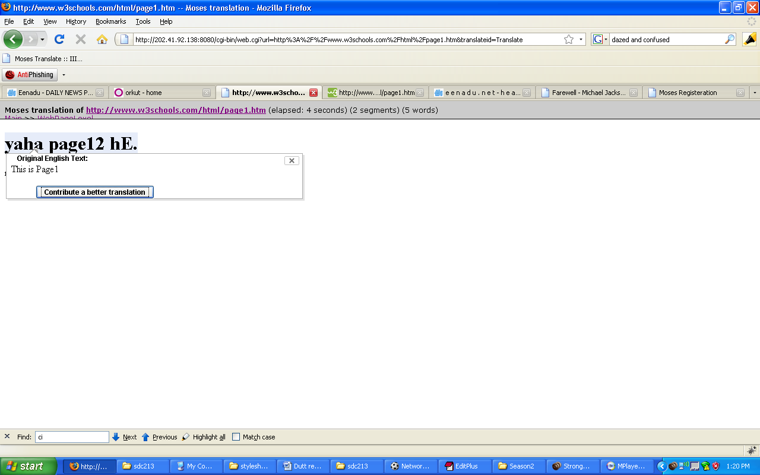
bpanel
mpanel.css --------- the main panel css file
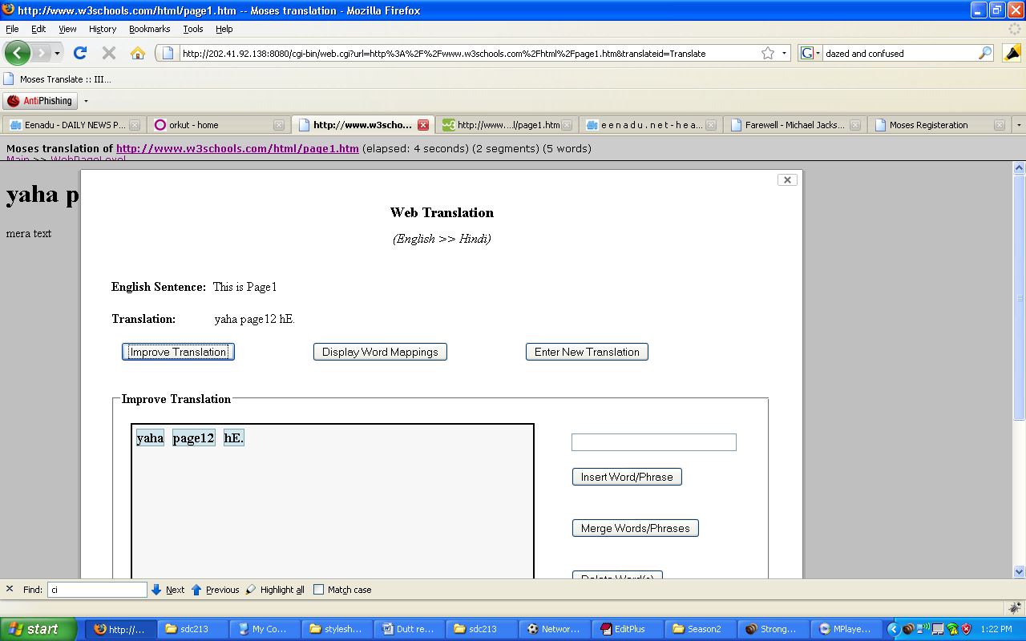
Mpanel
Container-core.css -------- the css file that is supplied by the yui (yahoo user interface) which forms the base for bpanel and mpanel.
gila.css ---------- the css file of the website
otpei_login.css -------- the css file of the login and registration page
otpei_stylesheet.css ----------- the css file of the sentence translation page
otpei_web_stylesheet.css ----------- the css file of the web translation page

Scripts
Animation-min.js, connection-min.js, container-min.js, dragdrop-min.js, yahoo-dom-event.js ------------ the script files that are supplied by yui.
editable.js ------ the script that is responsible for the editing of the words on double click.
otpei_source.js ------ the script that provide user interface for sentence translation.
otpei_web_source.js ------------- the script that provide user interface for web translation.
otpei_source_help.js ----------- the script that provide user interface for helpus page.

trans ------------------- that contains the moses files
Deamon.pl ------------ the code that keeps the moses in server mode.
Change the moses and moses.ini address at the starting of the code. Running this will keep the server in running mode. Usage ./deamon.pl ipaddress portno

moses.ini , otpei.lm, phrase-table.0-0.gz, reordering-table.msd-bidirectional-fe.0.5.0-0.gz ---- moses output files

How to deploy?
Make all the changes for the code files as said above. Start the moses by running deamon.pl. Place the files in cgi-bin and html folders in the respective folders in the webserver.
How to deploy it for another language translation system(English to Telugu)?
Just replace the moses output files in the trans folder

